CSE 483 Homework 4

Homework Objective: Provide students with the opportunity to work with .NET threading and UDP sockets.

Due Date: See Blackboard

Nework Tic-Tac-Toe Game

- You are to develop a WPF network Tic-Tac-Toe game, where each of the players can play the game from different computers on the network.
- You should start with your Tic-Tac-Toe game developed as part of Homework 2, and add UDP socket communications. You may also start with the Tic-Tac-Toe solution I provided on the Blackboard.
- The game should play just as it did for Homework 2. The UDP socket interface will be used to send messages back and forth to communicate player actions between two instances of the SAME Tic-Tac-Toe game, and keep the game boards looking the same for each player.



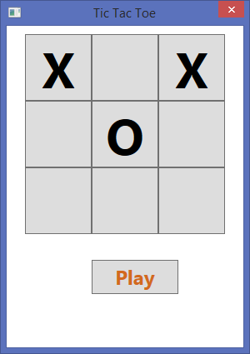

UDP/IP

Helpful Starters on the Black Board. All can be found in Content, Course Supplements
- Tic-Tac-Toe – Solution to single player game
- UDP Peer –Peer Example (Two way) – Example to show how to pass data over UDP, as well as synchronize 2 instances of the same peer over UDP
- Socket Setup Window – You will need this for the UDP Peer-Peer Example, and perhaps for your games.

Format: Provide the information as follows:

- Zip project files.
- Upload the zip file via the web to the Blackboard.
- Please include your full name as part of the header in each source file.
- Please append _HW4 to the .zip file name (e.g. waclawski_HW4.zip).

